1. **Agenda**: Redis Transaction.
2. Redis transaction is supported by this set of 5 commands.  
   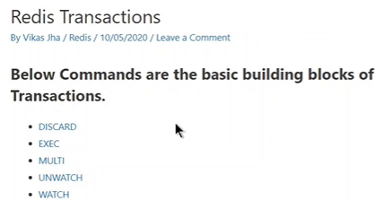
3. Let’s take an example for inconsistent transaction.
4. 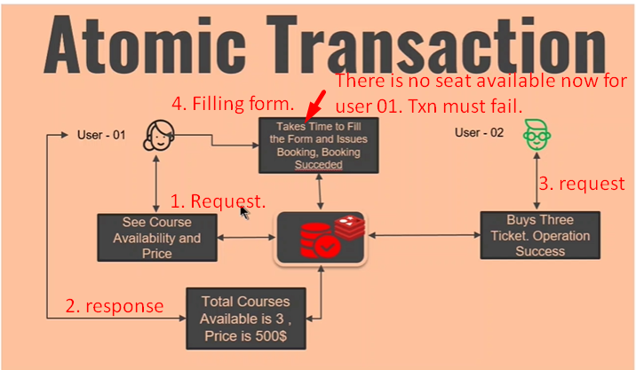
5. 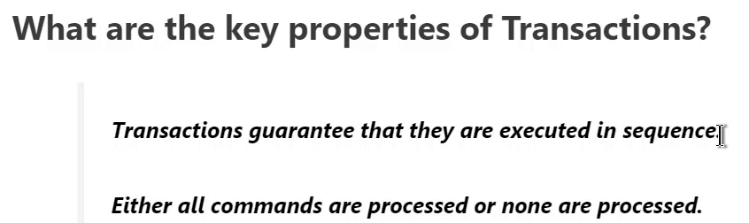
6. How to setup transaction?

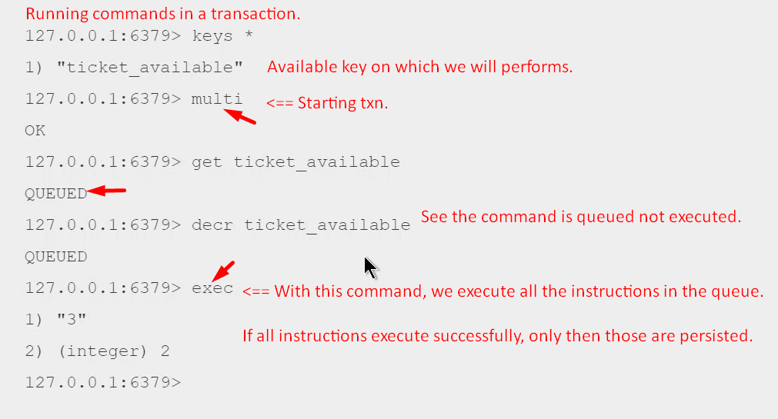

1. 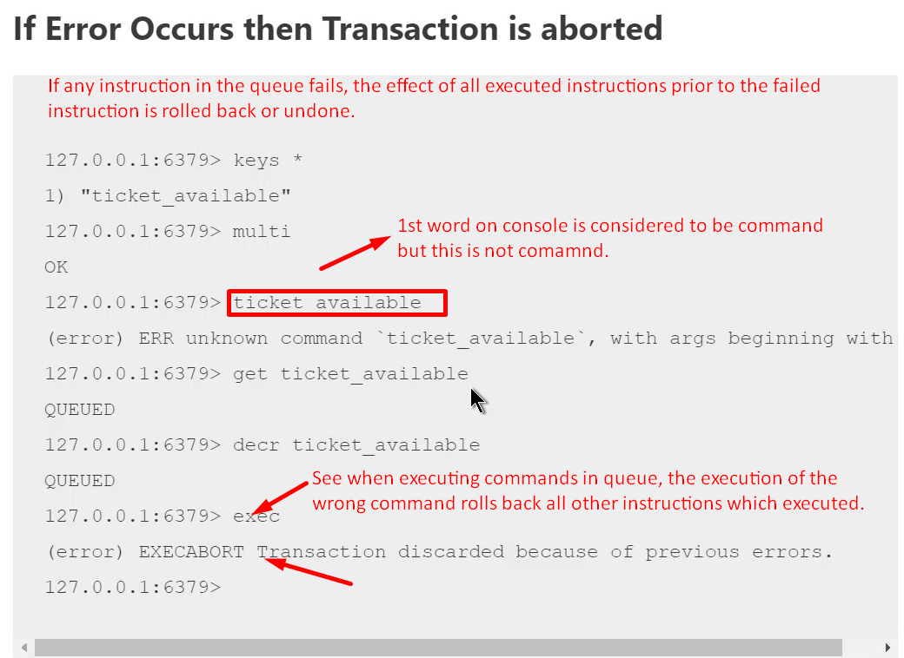
2. 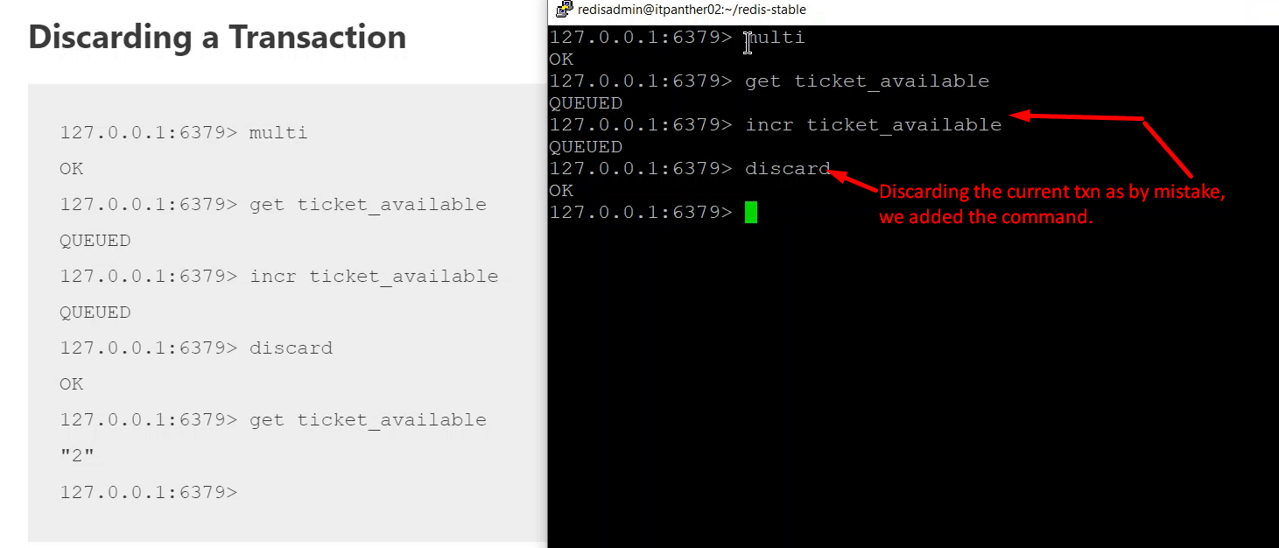
3. There is only one command prompt where we’re doing transaction till now.
4. Let’s see what happens we have two command prompts working on same key.
5. **Command** 🡺 watch, multi, exec  
   